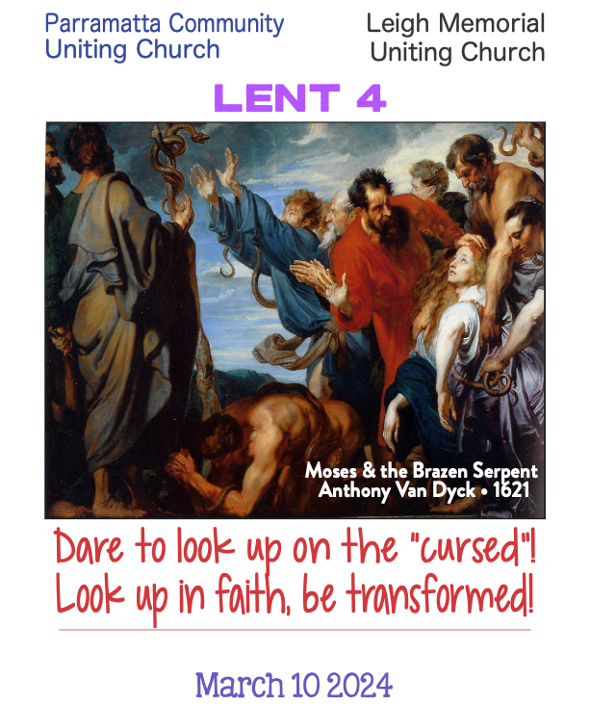

WELCOME
A warm welcome as we gather together.

LIGHTING OF THE LENTEN CANDLE
We light this candle
as a symbol of God’s faithful and loving support
of people in their Lenten journey.
The Lenten candle is lit

THEME Numbers 21. 4-9; John 3: 14, 16
14 And just as Moses lifted up the serpent in the wilderness, so must the Human One be lifted up ... 16 For God so loved the world that God gave the Beloved One for us ...
... a new relationship to face and transform the darkness and contradictions of life!

ACKNOWLEDGMENT
We acknowledge the Burramattagal people of the Darug Nation, the first inhabitants of this place, as the traditional custodians of this land and pay our respects to their ancient culture, their elders past and present and their emerging leaders. We acknowledge the presence of Aboriginal and Torres Strait Islander people who now reside within this area. We honour them for their custodianship of the land, on which we gather today.

OPENING SENTENCES
As we walk on into Lenten life,
we are gathered into the grace of God.
Here we may touch the depths of our lives
without the fear of being lost to love.
Here we may find riches and promises
which we have never unearthed before.
The Christ will walk beside us
as we enter each truth and face ourselves.
Thanks be to God for the courage of Christ.
The Lenten way will bring us
towards fullness of life.

A POEM THE SERPENT DIES
(Numbers 21: 4-9; John 3: 14-21)

No need to explain how the serpent’s bite
surfaces (stealthy as the coming of night)
while you’re reading the news; or worried and alone;
or when suffering long; or when a doctor intones
challenging words; or when darkness falls;
or the voice on the end of the telephone call
declares a once-loved relationship done;
when hope seems lost, when joy seems gone.

No need to explain how this serpent hides
next door to our hearts, marks left inside
where poison drips from the tip of its fangs:
in rage, in bitterness, in lonely pangs
of guilt and regret; in the resentments we bear.
And in hurts that we cause we do our own share
of spreading its toxin and resulting grief.
The serpent is death – the fear of it.

Relief
ever seems to elude us; but we may declare
its ultimate defeat; for above its shadow there
rises greater light – see, lifted up,
the one who for us drank the cup
of suffering, whose love even in death
conquered its evil; by whose living breath
we also may thrive. We turn trusting eyes,
snake-bitten, upon Christ, and the serpent dies.

Copyright © 2015 by Andrew King

hymn As Our Congregation… (Tune: ‘Nettleton’ 87.87D)
- As our congregation gathers
lift our lives, with love amaze;
offer some melodious treasure,
fill our hearts with wondering praise.

- Crashing brass and singing cymbals,
soaring organ, sound and light;
fill this space with awe and thunder,
lift us through the veil of night.

- Then a sudden, silent stillness
holds an echo in the air:
on a knife edge, balanced, waiting,
in the silence, you are there.

- Joy beyond imagination,
love incarnate, hope to hold,
faith we cannot sound or fathom,
gripped in wonder, we behold.

Andrew Pratt With permission OneLicense #A727308

ENTERING LENT
Just as Moses lifted up the serpent in the wilderness,
so must the New Human be lifted up,
that whoever trusts may have eternal life. — John 3.14-15

You have to look your evil in the face to be healed.
The snakes that plagued the Hebrews in the desert
were their betrayal come back to bite them,
their being Eden’s serpent.
The cure was to gaze at their wrongdoing.

So we gaze upon the Crucified One, our victim,
and look our awfulness in the eye
and only there grasp forgiveness,
and only then become truly alive.

On the cross is lifted up
our racism, our violence, our materialism,
our deep seated me-first-ism.
Posted there is our last text to God,
“I’ll let you know when I need you.”
We look at it, look at it hard,
to get free of the lie that we’re just fine,
the lie that keeps us from knowing
how deeply we are forgiven,
how vastly we are blessed,
how infinitely we are loved.
Amen
(Source: Steve Garnaas-Holmes, Unfolding Light)

WORDS OF ASSURANCE
Infinite Love, heart of all life,
you loved this world into being
with such love
as to birth yourself among us,
Love begotten as the Beloved.
Opening ourselves to your love
we live beyond our mortal selves
and join your eternal Oneness.
Your presence does not separate but unites;
love does not push away, but embraces;
you do not condemn, but liberate.
Trusting this we know
we are loved, never rejected.
When our trust fails we are doomed:
withdrawing into ourselves
we aren’t open to love,
the only source of life.
Amen!
(Source: Steve Garnaas-Holmes, Unfolding Light)

HYMN Comfort, comfort all my people

Chorus
Comfort, comfort all my people
with the comfort of my word.
Speak it tender to my people:
All your sins are taken away.
- Though your tears be rivers running,
though your tears be an ocean full,
though you cry with the hurt of living,
comfort, comfort.
Every valley shall be lifted,
every mountain shall be low,
every rough place will be smoother:
comfort, comfort.
Chorus
Comfort, comfort all my people
with the comfort of my word.
Speak it tender to my people:
All your sins are taken away.
2. Though your eyes see only darkness,
though your eyes can see no light,
though your eyes see pain and sorrow:
comfort, comfort.
Every night will have its morning,
every pain will have an end,
every burden will be lightened:
comfort, comfort.
Chorus
Comfort, comfort all my people
with the comfort of my word.
Speak it tender to my people:
All your sins are taken away.
Robin Mann With permission OneLicense #A727308

SCRIPTURE READING
Numbers 21:4-9
4 From Mount Hor they set out by the way to the Red Sea, to go around the land of Edom; but spirit of the people became short-tempered on the way.
5 The people spoke against Elohim, our God, and against Moses, “Why have you brought us up out of Egypt to die in the wilderness? For there is no food and no water, and the spirit of the people, she detests this miserable food.”
6 Then Yahweh sent fiery serpents among the people, and they bit the people, so that many Israelites died. 7 The people came to Moses and said, “We have sinned by speaking against Yahweh and against you; pray to Yahweh to take away the serpents from us.” So Moses prayed for the people.
8 And Yahweh said to Moses, “Make a copper viper, and set it on a pole; and everyone who is bitten shall look at it and live.”
9 So Moses made a viper of copper, and put it upon a pole; and whenever a serpent bit someone, that person would look up at viper of copper on the pole and live.

John 3: 14-21 (inclusive reading)
14 And just as Moses lifted up the serpent in the wilderness, so must the Human One be lifted up, 15 that whoever believes in this one may have real life.
16 For God so loved the world that God gave the Beloved One, so that everyone who believes in this One may not be lost but may have real life.
17 Indeed, God did not send the Beloved One into the world to condemn the world, but in order that the world might be transformed through this One.
18 Those who believe are not condemned; but those who do not believe are condemned already, because they have refused to believed in the name of the only Child of God.
19And this is the judgment, that the light has come into the world, and some have shown they prefer darkness rather than light because their deeds were evil.
20 For all who do evil hate the light and do not come to the light, so that their deeds may not be exposed. 21 But those who live by the truth come out into the light, so that it may be clearly seen that their deeds belong to God.”

RESPONSE
O God our nurturer,
may your word live in us.
And colour our living. Amen!

REFLECTION

HYMN Now the green blade rises (TiS, 382)
- Now the green blade rises from the buried grain,
Wheat that in the dark earth many years has lain;
Love lives again, that with the dead has been:
Love is come again, like wheat that springs up green.

- In the grave they laid him, Love whom we had slain,
Thinking that never he would wake to life again,
Laid in the earth like grain that sleeps unseen:
Love is come again, like wheat that springs up green.

- Up he sprang at Easter, like the risen grain,
He that for three days in the grave had lain;
Up from the dead my risen Christ is seen:
Love is come again, like wheat that springs up green.

- When our hearts are saddened, grieving or in pain,
By your touch you call us back to life again;
Fields of our hearts that dead and bare have been:
Love is come again, like wheat that springs up green.

John Macleod Campbell Crum With permission OneLicense #A727308

OFFERING An offering of our lives and the gifts of creation.

ANNOUNCEMENTS

PRAYER FOR OTHERS
On this fourth Sunday in Lent,
we bow our heads in prayer before you, O God.
Make us wise in praying,
that our love may be joined with yours
in reaching out towards those whose choices in life
are reduced to finding ways of surviving.

Shine your light on their faces,
so that we may pray with a passion for good.
Silent reflection
We pray for those who are close to our hearts now:

The people pray

May we be those who so love the world
that, like Jesus, we become known as those
who do not bring condemnation to others
but walk beside them in compassion.
Shine your light on all we do as your church, Jesus Christ.
Enable us to be those
who dare to come into that light ourselves
and to see what is of lasting value,
rather than passing attraction.

Especially as we walk towards Good Friday and Easter Day,
may we not fear what lies ahead of us,
but trust that you have gone before and made the way straight.
Refresh us, each day, with hope and grace
which flows from your holy Being in a never-ending stream.
This we pray in faith.
Amen.

HYMN Christ be my leader (TiS 624)
- Christ be my leader by night as by day;
safe through the darkness for he is the way.
Gladly I follow, my future his care,
darkness is daylight when Jesus is there.

- Christ be my teacher in age as in youth,
drifting or doubting, for he is the truth.
Grant me to trust him, though shifting as sand,
doubt cannot daunt me; in Jesus I stand.

- Christ be liberation in calm as in strife;
death cannot hold me, for he is the life.
Nor darkness nor doubting nor wrong and its stain
can touch my salvation: with Jesus I reign.
Timothy Dudley-Smith With permission OneLicense #A727308

BLESSING
Walk on in grace, for God is with us.

And may this time of Lent bring us closer to God,
the company of Christ bring us nearer to each other
and the leading of the Spirit renew each moment.
Amen.
D McRae-McMahon

HYMN Come as you are (TiS 693)
1. Come as you are, that's how I want you.
Come as you are, feel quite at home.
Close to my heart, loved and forgiven
Come as you are, why stand alone?

2. No need to fear, love sets no limits.
No need to fear, love never end.
Don't run away, shamed, and disheartened.
Rest in my love, trust me again.

3. I came to call sinners, not just the virtuous.
I came to bring peace, not to condemn.
Each time you fail to live by my promise
Why do you think I'd love you the less?

4. Come as you are, that's how I love you.
Come as you are, trust me again.
Nothing can change the love that I bear you.
All will be well, just come as you are.
Deirdre Brown, With permission OneLicense #A727308

