

**What is Grief & Loss?**

**Grief is the way we respond to the loss of someone or something important to us. Grief is a normal and natural response that can affect us all. It is important to know that there is no right or wrong way to grieve.**

**Some people will experience a broad range of intense feelings that could include shock, sadness, anger, guilt, or pain. While others may feel disbelief, relief, or numbness. Their world may feel like it is in chaos or out of control.**

**The processing of feelings, thoughts and physical reactions can leave some people feeling exhausted and emotionally drained. Others may barely get through the days or fill every minute of their time with activities.**

**Grief is a deeply personal and individual experience. How someone reacts and processes their grief will differ greatly depending on the circumstances around the loss as well as their cultural beliefs and traditions.**



|  |  |  |  |
| --- | --- | --- | --- |
|  |  |  |  |
|  | **FACTSHEET: GRIEF & LOSS** | |  |

***Some people may experience grief after a significant loss other than the death of a loved one including:***

* ***After a separation or divorce***
* ***A much-loved pet***
* ***Change of circumstances due to unemployment, retirement, or retrenchment***
* ***Illness, accident, or permanent disability***
* ***Infertility or miscarriage***
* ***Transitioning from their own home into an Aged Care Facility***

**FACTSHEET: TYPES OF GRIEF**



**Anticipatory Grief** – The process of dealing with anticipated loss related to diagnoses such as acute and chronic illness or terminal illness for the self or others.

**Acute Grief** - The time immediately after the loss when symptoms are the most intense and can last for several months afterwards. Generally, most people will not require treatment to process their grief.

**Disenfranchised Grief** – This type of grief is experienced when someone is not able to openly share or acknowledge their loss either privately or publicly. The person’s experience is not recognized, and they are unable to mourn in traditional ways.

**Complicated Grief** - Around 10% of people will experience this. Complicated grief is persistent, long lasting, and severe, it can be treated with Psychotherapy.

**Integrated Grief** – The time after resolving the symptoms of acute or complicated grief. The reality of the loss has been accepted, life and daily activities have resumed.



**William Worden’s**

**4 Tasks of Grieving:**

1. Accept the reality of the loss.

2. Process the pain of grief.

3. Adjust to life without the deceased.

4. Create a continuing connection with the deceased while embarking on a new life.

**Stroebe & Schut**

**Dual Processing Model of Grief**

**FACTSHEET: GRIEF & LOSS**

**When To Seek Help?**

If you or another individual are experiencing the following:

* Changes in appetite such as loss of appetite or overeating.
* Feelings of intense sadness, emptiness, or despair.
* Disturbed or changes in normal sleeping patterns.
* Thoughts of suicide or self-harm.

Contact your Doctor, Professional Psychologist, Counsellor or Psychotherapist, join a support group or talk to a trusted relative or friend.

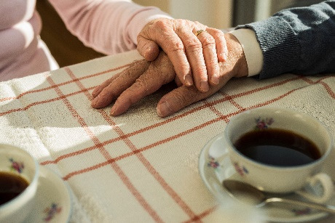

**Suggestions That May Help**

* Stay connected with the grieving person
* Be prepared to listen to them
* Offer practical ways to support them
* Share your own feelings about the loss
* Talk about the person using their name if culturally appropriate
* Keep trying to make contact even if there is no response first time
* Share memories and stories of the person who has died
* Remember and acknowledge significant events, dates, and special occasions

Sources

Healthdirect – [www.healthdirect.gov.au/grief-loss](http://www.healthdirect.gov.au/grief-loss)

Therapist Aid – TherapistAid.com

The Therapy Centre - [William Worden’s Four Tasks of Grief - The Therapy Centre](https://thetherapycentre.ie/william-wordens-four-tasks-of-grief/)

Counselling Tutor - [Dual Process Model of Grief • Counselling Tutor](https://counsellingtutor.com/dual-process-model-of-grief/)

Created by Kathleen Morris C2bMe 2021

**Helping OTHERS**

*Support Services*

Australian Centre for Grief and Bereavement.  
(<http://grief.org.au>)  
Phone: 1800 642 066

PalliativeCare Australia  
(https://palliativecare.org.au/)  
Phone: 02 6232 0700

Lifeline  
24/7 (http://www.lifeline.org.au/)  
Phone: 13 11 14

Beyond Blue  
(<http://www.beyondblue.org.au/>)  
Phone: 1300 22 4636