- The purpose of these two studies:
- To make ready for Holy Week and Easter;
- To reflect upon the imagery of the cross in the Christian faith;
- To do so in the time of a continuing pandemic.

- Our agenda:

- First thoughts: The Christian faith and suffering
Christ and Covid-19
Making comparisons
- Holy Week Meditations
- Stations of the Cross
- Martin Luther and the plague of 1527-29.

- First Thoughts:

The Christian faith and suffering:

- The first Christians often expected to share / partake in what was described as ‘the sufferings of Christ’. That suffering most likely took the form of persecution or mild to extreme forms of prejudice.
- The first Christians expected the imminent return of Christ; they were surprised when some of their own number died before Christ’s return.
- This experience of suffering was often [strangely] linked with joy (1 Peter).
- Their life of Christian witness in times of pandemic was shaped by an expectation of life after death, the call to love one’s neighbour as oneself, and the parable of the good Samaritan.
- To this list we could add for ourselves in this time of Covid-19 Matthew 25:34-40

³⁴ Then the king will say to those at his right hand, ‘Come, you that are blessed by my Father, inherit the kingdom prepared for you from the foundation of the world; ³⁵ for I was hungry and you gave me food, I was thirsty and you gave me something to drink, I was a stranger and you welcomed me, ³⁶ I was naked and you gave me clothing, I was sick and you took care of me, I was in prison and you visited me.’

³⁷ Then the righteous will answer him, ‘Lord, when was it that we saw you hungry and gave you food, or thirsty and gave you something to drink? ³⁸ And when was it that we saw you a stranger and welcomed you, or naked and gave you clothing? ³⁹ And when was it that we saw you sick or in prison and visited you?’ ⁴⁰ And the king will answer them, ‘Truly I tell you, just as you did it to one of the least of these who are members of my family,^{[g]} you did it to me.’

Christ and Covid-19:

- How we understand Christ in a time of Covid-19 can depend upon where we put our emphasis: on his life? On his passion and death? On his resurrection?
- One way into this question is by way of art: immediately there are questions that need to be answered.

      - What episode would you select?
      - ‘Who’ would you include?
      - Would you be contemporary or historical?
      - How would you ‘present’ Christ?

- The image below appeared on social media; it went viral; it was created by an anonymous artist. It generated divided opinion.

      - What do you ‘see’?
      - Which ‘senses’ are involved?
      - Where does the light fall?
      - How does it reflect Easter?
      - How does it ‘present’ Christ?

And then:

      - How does it compare with the classical works of
Caravaggio and Rubens?
- 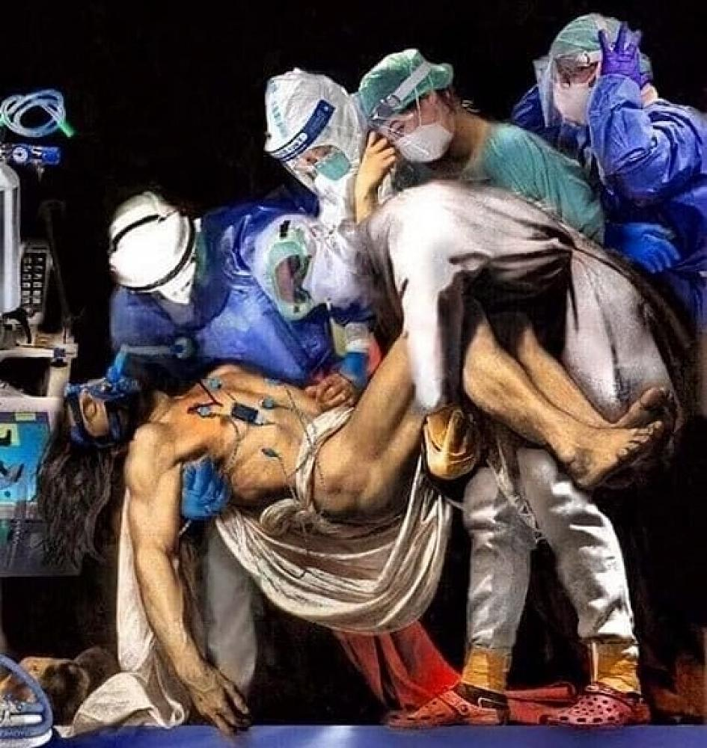Comparisons Caravaggio The Entombment of Christ

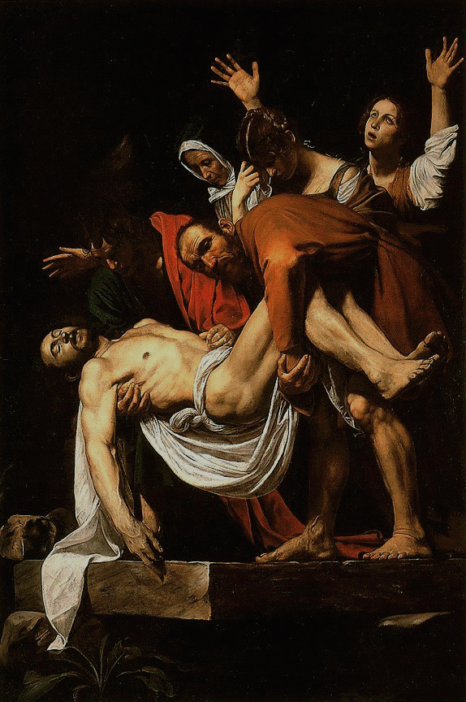

Rubens The Descent from the Cross

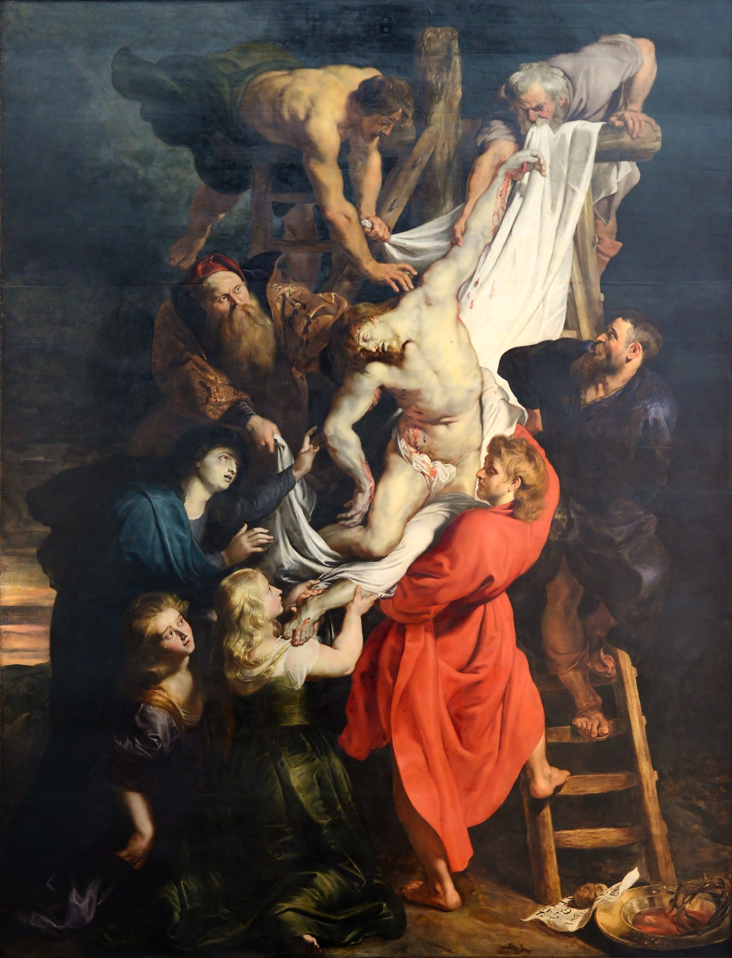

- Holy Week Meditations:

- The declaration of a pandemic coincided with Lent / Easter.
- There have been a significant number of Covid-19 based mediations featuring themes to do with ‘can’t breathe’, ‘do not touch’, masks, grief / weeping, loneliness and solitude, compassion.
- One rather lovely text (covering the year rather than just Easter) is Rowan Williams, Candles in the Dark: Faith, Hope and Love in a Time of Pandemic, (London: SPCK, 2020).

- Stations of the Cross:

- The Stations of the Cross are traditionally fourteen images that symbolize Jesus’ Journey to the cross.
- There are various versions of the Stations, or Way of Sorrows; they are a way of entering into deep reflection around the suffering and pain that Jesus experienced at the hands of the leaders of his own people, crowds and the imperial authorities.
- The Stations actually include ‘episodes’ or ‘stations’ not found in Scripture – e.g. Jesus falling along the way three times, the encounter with his mother and the encounter with ‘Veronica’.
- What might it mean to travel along this Way of Sorrows during a global pandemic? Below some stations are selected for comment.

Station 1: Jesus is condemned to death.

- In the passion narrative Jesus finds himself condemned to death: that is the outcome the Pharisees, the Sadducees, the Herodians, the chief priests and scribes have been seeking. It requires Pilate to be complicit, even if he is sceptical about the case being mounted against Jesus. It requires an act of betrayal—and, yet, at the same time Jesus is willing to undergo this sentence: ‘not my will, but your will’ according to his prayer in the garden of Gethsemane and in John: it is for this ‘hour’ that he has come so that the Son of God may be ‘glorified’.
- Prior to the rollout of vaccines there was no immunity to the ravages of Covid-19. How serious would the disease prove to be? Would it be fatal? Did it harbour a ‘death sentence’?
- Through the course of Christian history pandemics have meant ‘death sentences’ for large numbers of people—often on a daily basis. In response to the epidemic of 1529 Martin Luther write that one should go to church in order to hear the gospel proclaimed, in order ‘to live well and to die well’. How well that message has been conveyed in the contemporary church in Australia—and elsewhere—is doubtful.

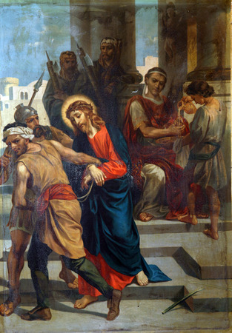
What do you ‘see’?
For someone who has contracted Covid-19 what words,
hymn, might speak to you of their plight and Christ’s suffering?

Scripture:
The Jewish leaders replied, “By our law he ought to die because he called himself the Son of God.” 8 When Pilate heard this, he was more frightened than ever. He took Jesus back into the headquarters[a] again and asked him, “Where are you from?” But Jesus gave no answer. “Why don’t you talk to me?” Pilate demanded. “Don’t you realize that I have the power to release you or crucify you?” (John 19:7-10)
Station 2: Jesus carries his cross.

- In each of the gospels Jesus invites those who follow ‘to take up their cross’. In response to an enquiry from James and John as to who is the greatest, he asks them whether they can be baptized with the baptism he is to undergo. That baptism is the cross. For those about to be crucified the practice was to have them carry their cross.
- The cross is not light. It is a burden that weighs one down. In a pandemic not only one who has contracted the disease is vulnerable and risk. So are all in contact and burdens multiply. Some are placed at great risk through loss of work and financial pressure—quite apart from health risks.

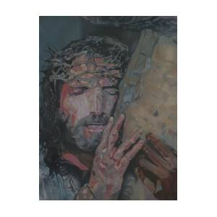
Jesus Carrying the Cross is a painting by Bennie Parker

What do you ‘see’?
What images from today suggest folk carrying their cross?
Scripture:
So they took Jesus, and carrying the cross himself he went out to what is called the Place of the Skull, in Hebrew, Golgotha. (John 19: 6, 15-17)

Station 3: Jesus falls for the first time.

- In the gospel stories there is no account of Jesus falling once, let alone three times. In this ‘popular’ account Jesus makes no attempt to draw upon his role as Messiah, Son of God, to assist him through these difficulties. Jesus resists such temptations. The idea of a stumble / stumbling block is, of course to be found in Paul’s letter to the church in Corinth. The cross is a stumbling block, a scandal to the Jews. It represents one who is accursed by God.
- Faced with a pandemic for the first time (in 100 years) there is plenty of scope for those responding to Covid-19 to stumble. They may miss the mark, fail to imagine consequences: even if they are well-intentioned they made be on the receiving end of the jeers of the crowd / media criticism / popular fear.

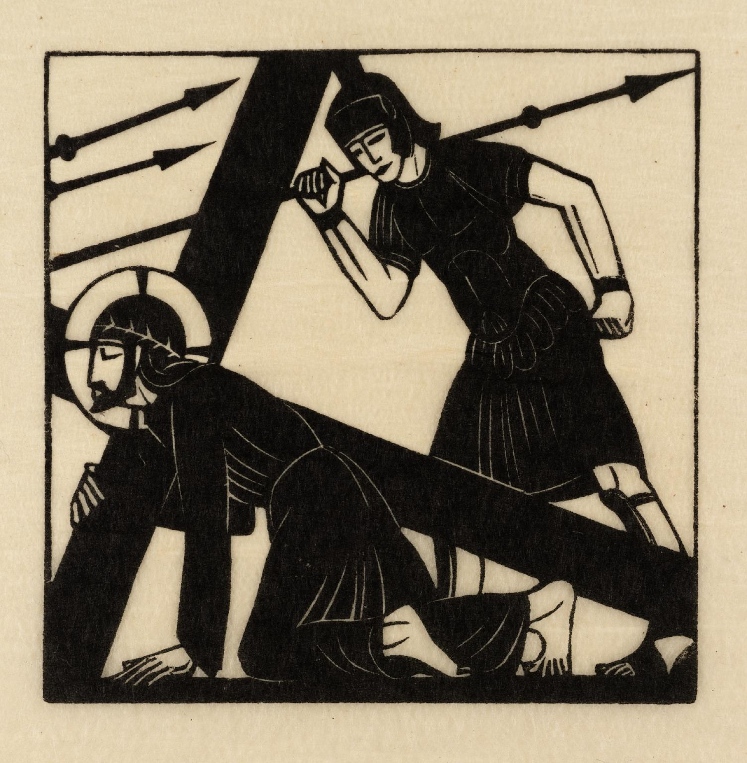

What do you ‘see’?
What burdens might cause a stumble?

Scripture:

Then Pilate took Jesus and had him scourged. And the soldiers wove a crown out of thorns and placed it on his head, and clothed him in a purple cloak, and they came to him and said,” Hail, King of the Jews!” And they struck him repeatedly. (John 19: 1-3)

Station 4: Jesus meets his mother, Mary.

- In each of the gospels Mary fulfils a different role. She is most present in Luke’s gospel—the conception, the Magnificat, the birth narrative, in the public ministry, at the foot of the cross. There is no account in the gospels of Jesus meeting Mary on the way to the cross as is sometimes portrayed in art and in the stations of the cross. In John’s gospel Mary is more distant: her first appearance is the wedding at Cana story; later she will show concern for Jesus’ state of mind; the request by Jesus of the beloved disciple to take care for her is peculiar to John.
- Consider the experience of mothers who have lost members of family or whose family situation has been rendered vulnerable. Consider the mothers who have found themselves needing to take leave of work to care / teach their children during Covid-19; consider the mothers who are health professionals and who have needed to be separated from their children.

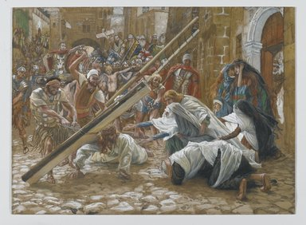

What do you ‘see’?
What ‘feelings’ / ‘emotions’ might a mother express in a time of Covid-19?
Scripture:
When Jesus saw his mother and the disciple whom he loved standing beside her, he said to his mother, “Woman, here is your son.” Then he said to the disciple, “Here is your mother.” And from that hour the disciple took her into his own home. (John 19: 25-27)

Station 5: Simon of Cyrene helps Jesus carry the cross.

- Cyrene is in Africa—hence the passer-by who helps Jesus out as he falls is an African. He does not represent a professional; he is someone who just ‘happens’ to be there; he has little option but to assist; why are his sons mentioned in the text? Is it because they become followers of Christ in the future?
- One of the stories that has emerged through this time of Covid-19 is that of Justin Welby, the Archbishop of Canterbury, acting as a ‘secret’ chaplain. On a regular basis he would make his way to a hospital, put on protective clothing and masks, and sit and pray with a suffering patient.
- In the course of the early history of the Christian church the followers of Christ were known for the care and assistance they gave to suffers of plagues. They were not compelled to do so because of some imperial or political authority. They did so for an inner reason which had to do with the summons to love one’s neighbour. The parable of the Good Samaritan loomed in the background.

- 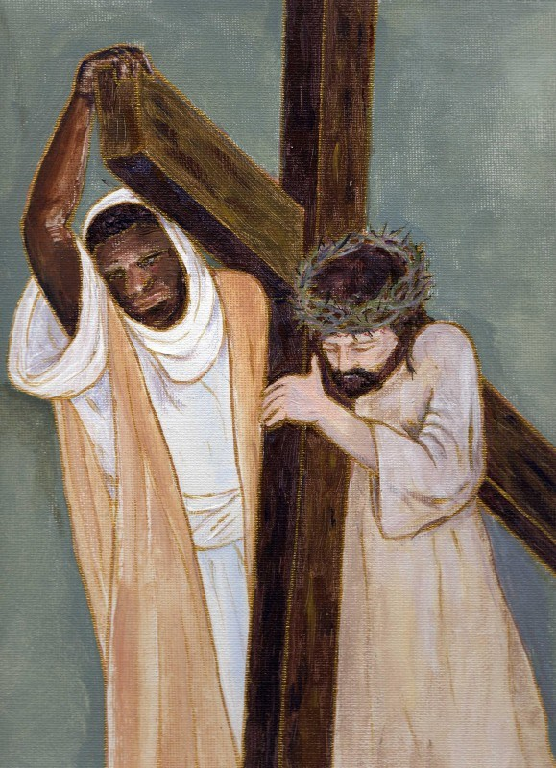

Scripture:
They compelled a passer-by, who was coming in from the country, to carry his cross; it was Simon of Cyrene, the father of Alexander and Rufus. (Mark 15:21)

Station 6: Veronica wipes the face of Jesus.

- There is no such character in the gospels. Veronica is an invention of a tradition. There are those who, like Veronica, risk their own lives to show kindness to the sick, vulnerable, and outcast. This station invites us to remember the healthcare workers and other essential workers who are putting their own lives at risk to help others.

Station 7: Jesus falls for the second time.
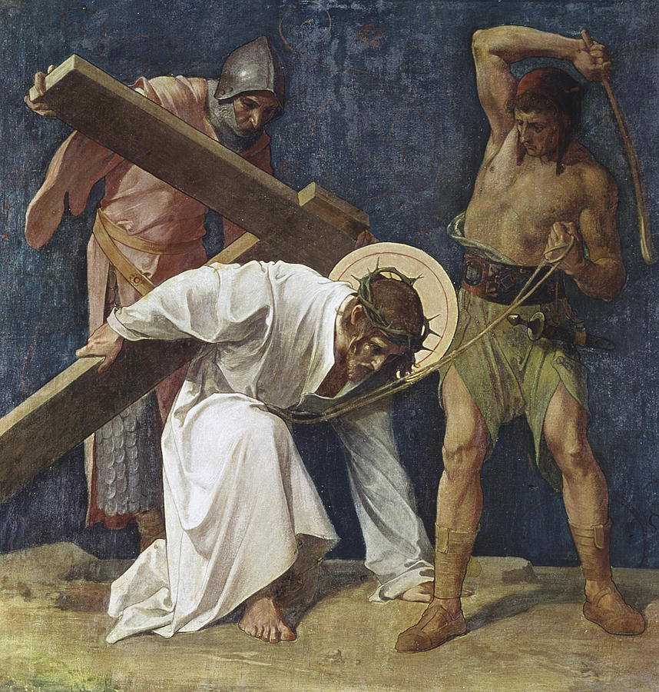

Scripture: Read again this passage for the second time:
Then Pilate took Jesus and had him scourged. And the soldiers wove a crown out of thorns and placed it on his head, and clothed him in a purple cloak, and they came to him and said,” Hail, King of the Jews!” And they struck him repeatedly. (John 19: 1-3)

Station 8: Jesus meets the women of Jerusalem.

Scripture:
But Jesus turned to them and said, “Daughters of Jerusalem, do not weep for me, but weep for yourselves and for your children. For the days are surely coming when they will say, ‘Blessed are the barren, and the wombs that never bore, and the breasts that never nursed.’ Then they will begin to say to the mountains, ‘Fall on us’; and to the hills, ‘Cover us.’ For if they do this when the wood is green, what will happen when it is dry?” (Luke 23: 28-31)

Station 9: Jesus falls for the third time.

Station 10: Jesus is stripped of his clothes.

Scripture:
They stripped him and put a scarlet robe on him, and after twisting some thorns into a crown, they put it on his head. (Matthew 27:28-30)

Station 11: Jesus is nailed to the cross.

Scripture:
Two others also, who were criminals, were led away to be put to death with him. When they came to the place that is called The Skull, they crucified Jesus there with the criminals, one on his right and one on his left. (Luke 23:32-33)

Station 12: Jesus dies on the cross.

- Jesus on the cross is at a distance form those who love him. There is no one touching him at the moment of death., As time passes it is more difficult to breathe.

Scripture:
It was now about noon, and darkness came over the whole land until three in the afternoon, while the sun’s light failed; and the curtain of the temple was torn in two. Then Jesus, crying with a loud voice, said, “Father, into your hands, I commend my spirit.” Having said this, he breathed his last. (Luke 23:44)

Station 13: Jesus is taken down from the cross.

- In the aftermath of death, we are faced with mourning, the effects of death on a community have a lingering impact. Many are dying alone, unable to see family and friends as they die. If they are lucky there is someone at the foot of their bed, like Jesus’ mother and some of his close friends were at the foot of his cross
- The taking down of the body from the cross is the moment of touch. Up until this time the senses involved are those of eye and ear. Touch is intimate. It is ‘felt’.

Scripture:

One of the criminals who were hanged there kept deriding him and saying, “Are you not the Messiah? Save yourself and us!” But the other rebuked him, saying, “Do you not fear God, since you are under the same sentence of condemnation? And we indeed have been condemned justly, for we are getting what we deserve for our deeds, but this man has done nothing wrong.” Then he said, “Jesus, remember me when you come into your kingdom.” He replied, “Truly I tell you, today you will be with me in Paradise.” It was now about noon, and darkness came over the whole land until three in the afternoon, while the sun’s light failed; and the curtain of the temple was torn in two. Then Jesus, crying with a loud voice, said, “Father, into your hands I commend my spirit.” Having said this, he breathed his last. (Luke 23:39-46)

The painting below is by Rembrandt.
What do you ‘see’?
How might it ‘speak’ into a context of Christ and Covid-19 and its experience of loss and death?

- 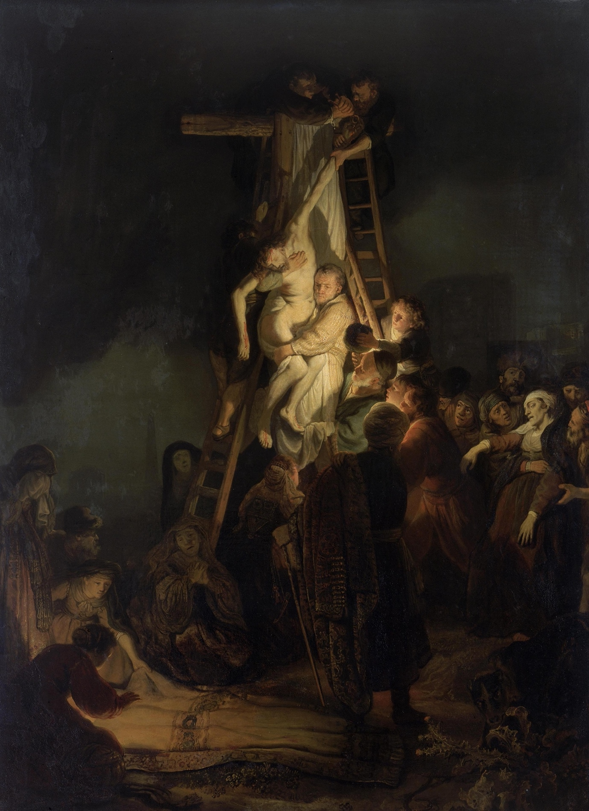

Station 14: Jesus is placed in the tomb.

Consider again this scene from the Isenheim altarpiece?
What kind of ‘message’ might it release for us today?
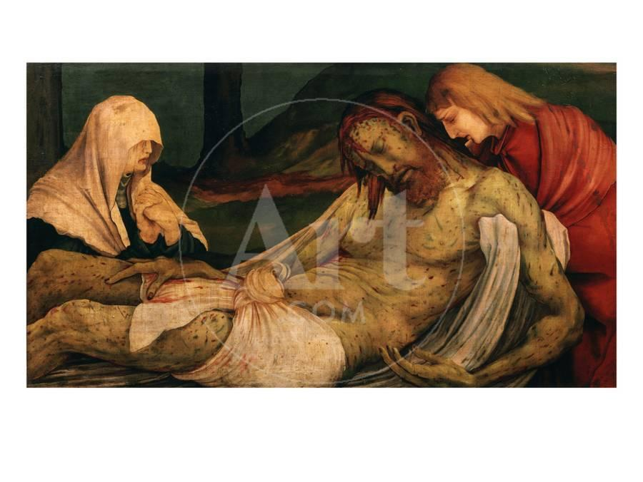

Scripture:
When it was evening, there came a rich man from Arimathea named Joseph, who was himself a disciple of Jesus. He went to Pilate and asked for the body of Jesus; then Pilate ordered it to be handed over. Taking the body, Joseph wrapped it [in] clean linen and laid it in his new tomb that he had hewn in the rock. Then he rolled a huge stone across the entrance to the tomb and departed. (Matthew 27: 57-60)

- Martin Luther: Whether Christians Should Flee the Plague

- The bubonic plague struck Wittenberg in 1527: Luther refused calls to leave the city: that refusal would cost him his daughter, Elizabeth. What comes down to us now is his tract from the time: Whether Christians Should Flee the Plague. It has not attracted the same kind of attention as Luther’s great treatises which sparked a Reformation but it stands as a clear presentation of a Christian response to an epidemic. It was written in response to Johann Hess, the pastor at Breslau, who was seeking advice.

- There is a distinction to be made, firstly, between those who hold office and those who do not. With reference to the former: We die at our posts. Christian doctors cannot abandon their hospitals, Christian governors cannot flee their districts, Christian pastors cannot abandon their congregations. The end result may have been the same, but at times Luther explained these injunctions with a little more delicacy. Those who were charged with a spiritual ministry—preachers and pastors, for instance—“must likewise remain steadfast before the peril of death”. This counsel was then supported by reference to a biblical text like the good shepherd laying down his life for the sheep (John 10:11). Towards the end of his letter Luther would advise on the importance of the need for preaching in order to “learn through God’s Word how to live and how to die”, the pastoral care of the dying and perhaps administer the sacrament. Those who held public office—like mayors and judges—were ‘under obligation to remain’ and to do so, likewise, on biblical grounds. In this instance Luther would cite Romans 13:4: “The governing authorities are God’s ministers for your own good”. Paid public servants—that is, city physicians, city clerks and constables—were not to flee “unless they furnish capable substitutes who are acceptable to their employees”.

- What is evident from ‘these instructions’ is Luther’s appreciation of the need to maintain a degree of public order. The way in which he recommended that key public officials and citizens remain was consistent with the need to maintain municipal homes and ensure hospitals adequately staffed to care for the sick. Such institutions should be sustained by pious legacies. Luther also sought out sound policy with regards burials and clarification as to whether cemeteries should be inside or outside the town; he himself declared that he did know whether “vapours and mists arise out of the graces to pollute the air”. In the face of such calamity Luther aspired after a cemetery to be a place of reverence and respect where the grieving might pray and consider the resurrection. For the sake of the living Luther saw the need for homes and places of assembly to be fumigated and the air purified.

- With regards those who did not hold public office Luther’s response relied on the deep-seated conviction that emphasized how a people are “mutually bound together’”; “we cannot desert one another or flee from one another”; “whoever wants to serve Christ in person would surely serve his neighbour as well”. Luther further argued that no one should dare leave his neighbour unless there are others who will take care of the sick in their stead and nurse them…..that is the test. “If someone is weak and fearful, let him flee in God’s name as long as he does not neglect his duty toward his neighbour but has made adequate provision for others to provide nursing care.”

- In a manner that might anticipate anti-vaxxers and those who protest against masks and social distancing Luther takes to task those who are “much too rash and reckless, tempting God and disregarding everything which might counteract death and the plague. They disdain the use of medicines; they do not avoid places and persons infected by the plague, but light-heartedly make sport of it and wish to prove how independent they are. They say that it is God’s punishment; if he wants to protect them he can do so without medicines or our carefulness. This is not trusting God but tempting him. God has created medicines and provided us with intelligence to guard and take good care of the body so that we can live in good health”.

- Luther suggests how those who have contracted the disease and now recovered should conduct themselves; he is particularly condemning of those who keep their infection a secret and in so doing contaminate and poison others: “the judge should take them by the ear and turn them over to Master Jack, the hangman, as outright and deliberate murderers”.

- There have been many virtual choirs during this time of Covid-19.

Some examples:

I’ll fly away: https://www.youtube.com/watch?v=br-PBWhdMiU

You’ll never walk alone. https://www.youtube.com/watch?v=6gpoJNv5dlQ

It is well with my soul https://www.youtube.com/watch?v=Qmo4qG26_iU

How can I keep from singing? https://www.youtube.com/watch?v=VLPP3XmYxXg&list=RDQmo4qG26_iU&index=2

